

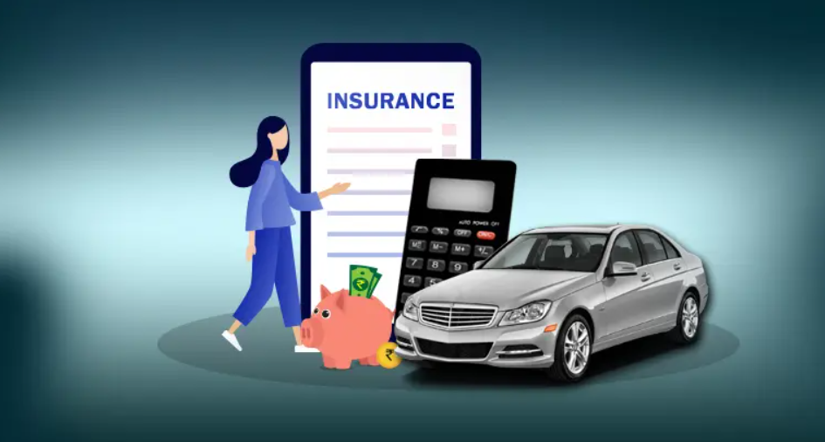

The Objective is to Analyse customers and their Insurance Claims data using Tableau Business Intelligence Tool.

**Project URL:**

[DVT_CarInsuranceclaim_project | Tableau Public](https://public.tableau.com/app/profile/manisha.parakandla/viz/DVT_CarInsuranceclaim_project/DetailAnalysisStoryLayout?publish=yes)

**This Tableau workbook is intended for the Car Insurance Company to support future**

**decision making for better performance and customer service.**



**Business Context**

We are all aware that accidents are prone everywhere due to negligent driving or climatic conditions. An insurance company always needs to be prepared to estimate the number of accidents and the claims that they can receive at a given point time. Also understanding the pattern of claims would help the companies to frame different types of policies for the users providing better benefits and at the same time increasing the premium to the company.

**Project Objective:**

The objective of the project is to explore “**Car claims for insurance.xlsx**” dataset and develop a clear logical story. Tableau Public software shall be used for analysing the data. For this purpose, I have assumed that the insurance company wants to increase their business in terms of scale and profitability and wants some insights by exploring the historic data.

**Assumptions:**

🡪There are several factors which are provided in the dataset. However, there may be other

unseen factors that are not considered

🡪 Assume the dataset has no missing data, otherwise the analysis will not be useful.

🡪YOJ and birthdate will lead to number of years/age computed as at 2021.

🡪The dashboard presented are intended to analyse the car insurance claims in details, in order for the insurance company to have an informed understanding of their customer base and to provide a better customer service.

**Data Dictionary:**

The dataset has data on 7647 client’s car insurance information, it includes the customer demographic information (birthdate, income, value of house owned, marital status, gender, education level, occupation, travel time.), the insurance claim information (worth of car, claim amount, claim frequency, age of car etc).

|  |  |
| --- | --- |
| Assumption | Car Owner and Driver are same Amounts are in Dollars ($) |
| ID | Identification Variable |
| KIDSDRIV | Number of teenagers among the car owner's children who can drive a car. |
| BIRTH | Date of birth of the driver |
| HOMEKIDS | No of children the car owner has |
| YOJ | Years on Job. How many years has the owner of the car been working? |
| INCOME | Income of the driver |
| PARENT1 | Is the car owner a Single Parent |
| HOME_VAL | Value of the house owned by the car owner |
| MSTATUS | Marital status of the car owner |
| GENDER | Gender of the driver |
| EDUCATION | Maximum Education level of the driver |
| OCCUPATION | Occupation of the driver |
| TRAVTIME | Time taken to get to work on an average |
| CAR_USE | Purpose of using the car |
| BLUEBOOK | What is the worth of the car, Value of the Vehicle (in dollars) |
| CAR_TYPE | Car type |
| OLDCLAIM | Total claim (in past 5 years - in dollars) |
| CLM_FREQ | Number of claims (in past 5 years) |
| CLM_AMT | If car was in a crash, what is the currently claimed amount (in dollars) |
| CAR_AGE | Age of car |
| URBANICITY | Where the car is being driven primarily |

**Relationship between these variables shall be studied and insights shall be drawn to help the insurance company to improve their business. The objective is to find insights in the Car Insurance data using Tableau for in-depth decision making and customer service.**

**Detail Analysis Story:**

1. **Claim Amount Analysis:** Private SUV car type draws highest claim in total claim, ‘Panel Truck’ draws lowest claim. Female blue-collar customers have highest claims. Female Doctor customers have lowest Claims.

2. **Claim by Car type analysis:** Minivan have more Travel time with highest Total claim frequency. Whereas panel truck has lower claim frequency. SUV private car is having highest claim.

3. **Claim Analysis by Gender:** Female customers have more claims. Married males claim is lower as compared to female. Specifically unmarried female customers with private SUV claim the highest.

4. **Top N Customer:** View of Top Customers with current claim amount has been provided to enable company to filter and analyse details of customers further and formulate targeted marketing.

5. **Average Claim analysis** by Selection Dimension.

6. **Claim Analysis of Occupation and Education** by Selection Dimension: combining Education with Occupation it has been observed that High school with blue collar customers claim highest followed by Bachelor’s degree professional.

7. **Claim analysis by Car Age:** Cars which are 1 year old have highest claim frequencies followed by significant claims from 7th,8th or 9th year cars

8. **Claims KPI and Growth rate:**

**Claims KPI:** Slider for KPI target has been provided for user to check performance of each car type against KPI. This would provide insight on which car type to change policies/ insurance amount and marketing strategy.

Claim rate slider has been provided for user to check the impact on total claim against growth rate and compare current claims against goal. Here, we have created calculated field ‘insurance year’ and ‘What if claims’ to create the What if graph.

**D1. Claim Amount Analysis:**

1)      SUV tops in number of claims as well as the amount claimed across all segment of cars

2)      Claim amount in Pickup type car is more than Minivans even though the number of claims in minivans are more.

3)      Claim types are more by Females across most types (except managers and professional) of occupation

4)      More than 32% Claim amount across all segments of cars comes from SUV

5)      More than 50% of total claim amount in car segments is by SUV and Pickup type cars alone.

**D2. Car type analysis:**

1)       SUV is the most extensively used type of car having maximum travel time, compared to other types of cars.

2)      Minivans have the maximum car age, indicating they are used for longer time span

3)      SUV has the maximum number of claims

4)      Panel trucks if used for private purpose does not register claim.

5)      Travel time of Minivan is much more than Pickup car (by ~40%) but still the claim amount from Pickup is more than minivan.

**D3. Claim Analysis by Gender:**

1)      Married person both male and female have lesser claim amount

2)      Claim amount of female is more than male irrespective of marital status

3)      Word cloud indicates SUV private has highest claim followed by Sports private and pickup commercial.

4)      From tree map we can infer SUV driven by Female have most claims both private and commercial

5)      From tree map we can infer Pickup and Minivan driven by Males have most claims.

**D4. Claim Amount Analysis:**

1)      Doctors have the least claim amount

2)      Female homemaker has the most claims compared to male counterpart.

3)      Blue collar profession has the highest claim amount

4)      There are no claims of Panel Truck used by Doctors or Lawyers

5)      In lawyer category of occupation Female lawyers have more than double claim amount as compared to male lawyers.

**D5. Average Claim Analysis:**

1)      It can be inferred that drivers with DOB 1931-32 have mostly claims, followed by those having DOB 1982.

2)      Panel trucks have the highest average claim amount

3)      Commercial cars have more claim than private

4)      Students below high school have the highest claims followed by those in high school. Cars driven in Urban cities have higher claims.

5)      Cars driven in Urban cities have higher claims

**DB6_Claim Analysis by Occupation:**

1)      Most claims for car type minivan, pickup, sport car is driven by people having blue collar occupation

2)      Most claims for car type Panel truck & Van are driven by male.

3)      Most claims for car type Panel truck are driven by professional people.

4)      Most claims for car type sports car & SUV are driven by female.

5)      Car type van driven by female does not have any claims

**DB7_Claim Analysis by Car Age:**

1)      Cars of age 1 years have most claims.

2)      Claims are less (less than 100 claims) for cars of age 2 to 3 years or more than 18 years.

3)      Claims from Cars of age more than 11 years are mainly (>2/3) of private usage.

4)      We see an increase of claims in cars of age 8 to 10 years.

5)      Claim decreases for cars of age more than 9 years.

**Calculated Field:**

Claims KPI: Slider for KPI target has been provided for user to check performance of each car type against KPI. This would provide insight on which car type to change policies/ insurance amount and marketing strategy. Claim rate slider has been provided for user to check the impact on total claim against growth rate and compare current claims against goal.

Here we have created calculated field ‘Insurance Year’ and ‘What if claims’ to create the What if graph.

We have used some more on project like Average claim, claim amount selector, education occupation, index, KPI setter, selection of dimension, total claim, year of manufacture.

**Conclusion & Inference:**

1). The high amount of claims means low profit for the premium paid by customers.

2). Company should consider in their strategy and insurance policy for SUV vehicles, Unmarried Female customers, blue collar with high school education customers, Customers with Private Minivans.

3). As this group of customers having high claim history as per the given data. The company can classify accordingly and decide to increased premium.

4). Company can provide some benefit for low claims to attract and maintain the customer base. Panel Truck customers need to be further analysed to check if claim is low as number of Panel trucks covered under insurance with company is low and claim itself is low.

5). Claims KPI would provide insight on which car type to change policies/ insurance amount and marketing strategy. Claim rate indicates the impact on total claim against growth rate and compare current claims against goal.